Lab 3 - Routing Protocol

NAME:
MATRIC NUM.: SECTION:
INTRODUCTION
This lab looks into the network layer, focusing on subnetting and routing.

TOPOLOGY

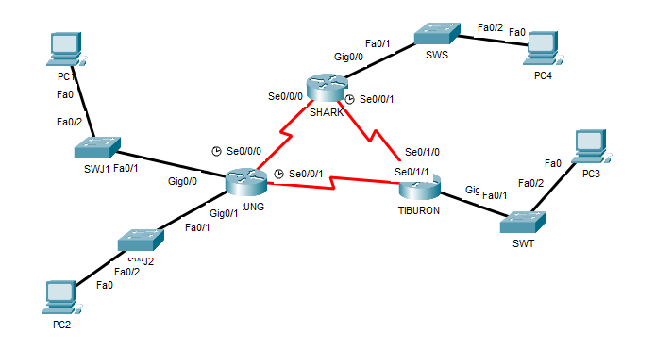

LAB INFORMATION
Here is some basic information for the lab. The network address given is 172.18.110.0/23.
Table 1

Device | Subnetwork | Usable Hosts
JERUNG | LAN1 | 20
 | LAN2 | 30
SHARK | LAN | 60
TIBURON | LAN | 50
Connections | JERUNG-SHARK | 2
 | JERUNG-TIBURON | 2
 | SHARK-TIBURON | 2

Table 2

# | Device  Name | Interface | IP Address | Subnet Mask | Gateway
1 | JERUNG | Se0/0/0 | 172.18.110.193 | 255.255.255.252
2 |  | Se0/0/1 | 172.18.110.197 | 255.255.255.252
3 |  | G0/0
4 |  | G0/1
5 | TIBURON | Se0/1/1
6 |  | Se0/1/0
7 |  | G0/0
8 | SHARK | Se0/0/0
9 |  | Se0/0/1 | 172.18.110.201 | 255.255.255.252
10 |  | G0/0
11 | PC1 | -
12 | PC2 | -
13 | PC3 | -
14 | PC4 | -

LAB TASKS

Task 1 – IP Addressing
- Given the network address of the organisation and the basic information provided in both Tables 1 and 2. Show your workings here and complete Table 2 with the correct information. PCs will be given the last usable address of the subnetwork.
- Using the IP addresses calculated, configure the devices with the appropriate information.

Task 2 – Routing Table
- Paste the current routing table of each router here. There are 2 ways to this – via CLI and via Packet Tracer (PT) tool. Use both ways to show the routing table of all the routers.
  - CLI
    - Click on a router. In the prompt, type show ip route. The routing table of the router will be shown, as shown in Figure A.
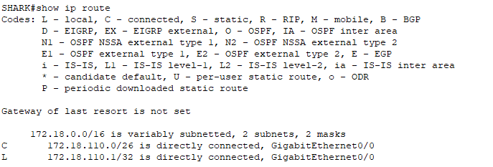
Figure A
  - PT tool
    - Click on the magnifying glass (shown in Figure B), then click on a router, then choose Routing Table. A sample of the result is shown in Figure C.

Figure B
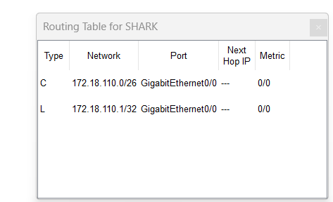
Figure C
- Try to ping PC2 from PC1, paste the results here.
- Try to ping PC4 from PC1, paste the results here.
- Explain the reason(s) behind the results.
- What needs to be done to ensure all PCs can ping each other successfully?

Task 2 – Routing Configuration
- Let’s start by opening the routing table (using the PT tool) for TIBURON and JERUNG. This is done to show changes to the routing table as configurations are made.
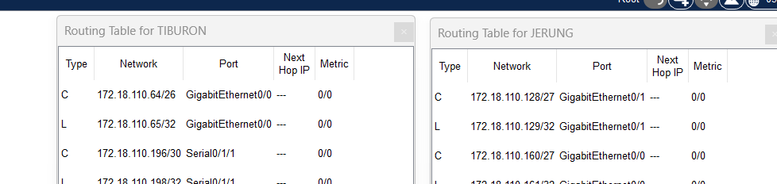
Figure D
- In router JERUNG, configure the RIP routing protocol as shown in Figure E.
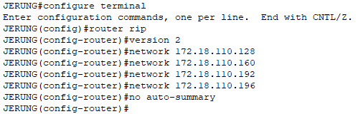
Figure E
  - What can you say about the addresses used in the ‘network’ instructions in Figure E?
- Then configure RIP in TIBURON. All are similar except use the network address. Use the instructions as shown below.
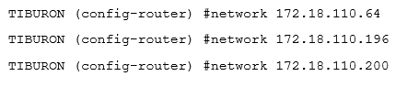
- As you may have seen, there are changes in the routing tables of both TIBURON and JERUNG. Paste a copy of these routing tables here.

  - What are the changes seen in TIBURON?
  - What are the Networks with type R in TIBURON and JERUNG?
  - Ping PC3 from PC1. Was it successful?
  - Ping PC4 from PC1. Was it successful?
  - Explain the reasons for your answer.
  - Continue with configuration of RIP in SHARK. Paste your configurations here.
  - Open router SHARK’s routing table and paste here.
  - Try to ping from PC4 to all other PCs in the topology. *Note: Try to ping at least twice to get best results.
PC | Ping result
1
2
3

Task 3 – Routing Update
- Let’s try a little experiment. Change the IP addresses of router TIBURON interface G0/0 to 192.168.1.1/24.
  - This means that the subnet has changed. Find the new Network address of this subnet. Network Address is: __________________
  - As this change happens, PC3 must also have different IP address, subnet mask and gateway address. What will it be?
PC3 | Info
IP address
Subnet Mask
Gateway Address

  - After this change, can PC4 and PC1 ping PC3?
  - Copy and paste the routing tables for both SHARK and TIBURON here.
  - Referring to the routing table, explain your findings.
  - What is your next move to ensure end-to-end connectivity (i.e. all PCs can ping each other successfully)?
  - Show your configurations in TIBURON to ensure end-to-end connectivity.
  - To ensure end-to-end connectivity, ping to all the PCs from PC3.
PC | Ping result
1
2
4

REFLECTION
What have you learned in this task?

